

SPRINT 1 DOCUMENTATION

Group 15

Email: [capsulefy.communications@gmail.com](mailto:capsulefy.communications@gmail.com)

Website: <https://capsulefy02.herokuapp.com>

GitHub: <https://github.com/pabreblob/capsulefy/releases> (Release 2)

Cantón Fernández, Adrián

Carpio Camacho, Daniel

Fresno Aranda, Rafael

Rebollo Lobo, Pablo

Rodríguez Regidor, Juan

Index

Introduction 2

Business Idea 2

Development team 2

Competitors analysis 3

Cost estimation 4

Development planning 5

Team members performance measurement 5

Sprint 1 initial planning 7

Sprint 1 status after Week 1(March 22th) 7

Sprint 1 status after Week 2(March 29th) 10

Lessons learnt 12

Items produced as result of the sprint 13

Sprint 2 planning 15

Week 1 (April 1st- April 7th) 15

Week 2 (April 8th- April 12th) 16

Piloting plan 16

Test case suite 16

Not logged user 16

Free capsules 16

Premium capsules 17

Important dates for our piloting plan 17

User form 17

User manual 17

Testing environment and credentials 17

# Introduction

The aim of this document is to provide information about the planification for this first sprint, the tasks that have been carried out and their results, as well as the conclusions the development team has arrived to after these two weeks. A quick overview of the business idea , team roles and costs is also provided, but for more extensive information about this topic please refer to the “Devising a project” document.

# Business Idea

Capsulefy is an online time capsule that allow users to store their memories and share them in the future. Users will be able to create a time capsule, attach a message to it, load files such as videos or images into it and set a date when they want the capsule to be released.

The capsules can also be connected to the user’s social networks so that a message is automatically posted when the capsule is published. Users will also be able to select a list of emails that will receive a notification message.

One of the main selling points of our product is allowing people to leave a message behind in case they pass away. For this reason, we will offer a dead-man switch option that once activated, will automatically release the capsule regardless of its publication date if the user hasn’t refreshed the counter after a certain period of time.

Our capsules also offer extra features such as the possibility of splitting them into different modules, each of them with a different release date, or making them private so that they won’t appear when listing the capsules.

We will be offering two different types of capsules: Free and premium capsules.

Each registered user will be able to create free capsules and upload files to them up to a maximum of 20mb in total. These capsules can be scheduled up to one year in the future and will be deleted 6 months after their release. These capsules can’t be made private, split into modules or have a dead-man switch set up

Premium and modular capsules will cost 11.99 € each, can store up to 500mb of files and will not have a limit on how far into the future they can be scheduled, nor will they disappear after being released.

# Development team

Our team is composed by five members, each one with different roles and responsibilities:

* Pablo Rebollo Lobo. His roles are project manager and backend developer. His main technological competencies are Spring, Django and PHP.
* Adrián Cantón Fernández, whose roles are business manager and full-stack developer. His main technological competencies are Django, Java and Bootstrap.
* Daniel Carpio Camacho, analyst and frontend developer. His main technological competencies are Django, JavaScript and Bootstrap.
* Juan Rodríguez Regidor, whose roles are requirements engineer and backend developer. His competencies are Django, Python and Bootstrap.
* Rafael Fresno Aranda. His role is backend developer and will also be in charge of the interaction of our product with other applications. His main technological competencies are Node.js, Django and PHP.

Our commitment as a team is to develop our business idea in order to create a minimum viable product in a good enough state so that it can receive appropriate feedback to decide whether or not release the full version to the market and apply that feedback to improve our product.

To reach this goal, we are compromised to meet the deadlines, listen to the feedback and cooperate within the team so that we can provide a product that meets our quality standards.

# Competitors analysis

We did a market research in order to determine which existing online services our product will be competing with, which are their main features and what makes our product different from them. We found 4 other similar services. The results of comparing them to our product are the following:

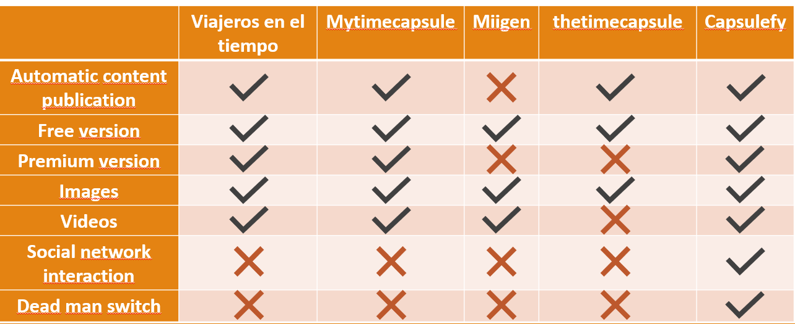

Figure 1: Competitors analysis table

We reached the conclusion that we are treading into an already existing market, but an undeveloped one, where we can offer features that makes us distinct from our competitors, such as the interaction with social networks and the publication of content in case the user has not logged in for a very long time.

There are other indirect competitors, such as official last wills or more traditional methods of sharing memories like photo albums, but they won’t be able to offer the possibility of quickly sharing their contents online.

The innovation of our app are these two features no other application similar to us provides: The dead man switch and social network interaction. While the development of these features does not imply that we are innovating from a technological viewpoint, since we will be using already existing technologies (OAuth, API calls…), the way we are incorporating them into our business model is something new that has not been tried by our more direct competitors. Thanks to these features, our service is highly customizable so that every user can tailor their time capsules to their needs.

# Cost estimation

Because we will be using Google Firebase to store all the files our users will upload to our system, we need to take into account the individual cost per user. By using Amazon S3, we will be charged 0.026 USD per GB per month.

Assuming we will be offering 500mb of storage in each of our Premium/Modular capsules, the cost of maintaining each 500mb capsule yearly is 0.156 USD (0.14€).

Assuming free users have 20 mb of storage, the yearly cost of maintaining a free user will be of 0.00624 USD (0.0127€).

In order to decide our storage and hosting funds, we will consider the cost of maintaining 2,000 premium capsules and 20,000 free users for a year, as well as an estimation of the cost of hosting our website and our database.

Our team has come up with 4 different cost estimations: A pessimistic one, an optimistic one, and two realistic estimations. These estimations cover costs during the development of our product, whose duration will be of 4 months, and some funds which may be used in order to deal with the risks that appear during the development or to cover initial server and advertisement costs. The factors that will affect our budget are the following:

* Team members’ salaries.
* Hardware amortization.
* Advertising funds for the first 6 months.
* Storage and hosting funds for the first year.
* Risk prevention funds.
* Taxes.

Because we will be using Google Firebase to store all the files our users will upload to our system, we need to take into account the individual cost per user. By using Amazon S3, we will be charged 0.026 USD per GB per month.

Assuming we will be offering 500mb of storage in each of our Premium/Modular capsules, the cost of maintaining each 500mb capsule yearly is 0.156 USD (0.14€).

Assuming free users have 20 mb of storage, the yearly cost of maintaining a free user will be of 0.00624 USD (0.0127€).

In order to decide our storage and hosting funds, we will consider the cost of maintaining 2,000 premium capsules and 20,000 free users for a year, as well as an estimation of the cost of hosting our website and our database.

As for advertising funds, firstly we have to determine a target audience. Our product is targeted to people who regularly uses internet and social media. The age segments targeted are young people and middle-age people.

Our goal is to advertise ourselves on the internet. For that reason, we will be using google ads. Because we offer integration with Facebook and Twitter, reaching out to the users of these platforms is also considered a key aspect of our marketing strategy.

Google ads charge business for each time their advertising is clicked. Each business can set how much they can be charged, and depending the price set, their ad will be more visible.

Because we are a small company, we will be setting the cheapest price possible within the range of prices our possible competitors for that ad spot pay, which is one of around 220€ per month, with an estimated performance of 137‑229 clicks per month

Facebook also allows us to customize how much would be willing to spend on a weekly basis. We have decided to spend about 140€ monthly for a Facebook advertisement which targets people of between 18 and 50 years old.

Same as Facebook, Twitter allows us to set a daily price. We will be using a similar budget to the one for Facebook, 5€ daily, which means ~150€ monthly for an audience between 18 and 49 years old.

In conclusion, we will be spending approximately 510€ monthly in advertisement. If in our project costs we are going to include the cost for the first 6 months, we will have a total cost of 3060€.

After these first 6 months, we will evaluate how this approach is performing, and depending on that we will decide whether increase or decrease our budget.

# Development planning

We will develop our product following the SCRUM methodology. The development of our prototype will be split into three sprints. The results generated from each sprint will be the following:

* Sprint 1: Prototype with working core use cases and a piloting plan in order to start gathering feedback.
* Sprint 2. Full working MVP. This means that not only the core use cases will be implemented, but also the payment module, the registration module and the basic admin will be working. The core use cases may be to need adapted according to the feedback resulting from the previous sprint.
* Sprint 3: Polished MVP which will take into account all the feedback from previous sprints.

# Team members performance measurement

In order to measure our productivity, we will be using Toggl. At the beginning of each sprint, we will have the tasks with their corresponding time estimation. At the end of the week, the estimated time will be divided by the real time invested in that task. This will be the efficacy ratio of this task. For each team member, the mean of their efficiency will be calculated, and it will be the member’s performance ratio. If the task is left unfinished, their ratio will be used in order to calculate a member effectivity if its <1, because a unfinished task should only affect negatively to the efficiency ratio of a person and not the other way around. A ratio between 0.8 and 1.2 is considered the expected performance.

A ratio between 1.2 and 1.5 is considered as more efficient than expected, and a ratio bigger than 1.5 is considered more efficient than desired and the causes for this will be investigated.

A ratio between 0.8 and 0.5 is considered less efficient than expected, and a ratio smaller than 0.5 means that there have been major issues with that task and the reason why will be investigated.

Besides this ratio, it will also be taken into account whether or not a user has finished his tasks, and in case there are some tasks left unfinished, we will try to find out the reason and act accordingly.

We considered whether or not measure the project manager efficiency using a different method. We came to the conclusion that it was better not to in order to maintain consistency with the other ratios, as he will also be doing tasks that can be measured in time and in their completion status, just as the other members.

Reasons why the performance may be better than expected:

* The tasks assigned to a member where easier than expected and therefore, took less time than the estimated. It will be taken into account so that he may receive a bigger workload in the future and the member will be suggested to review in depth the work he has carried out if he finishes it in less time than expected.
* Bad time estimation for that task. For the next set of similar tasks, their estimated time will be reduced until it is similar to the one that carrying out that task took.

If the performance is worse than expected, it is a bigger problem than taking less time than expected. The reasons why this may have happened are the following:

* Bad time estimation, just as when it takes less than it should. The same protocol previously mentioned applies to this case.
* A team member is not working properly. The member will be told that his attitude must change and will be closely monitored for the next set of tasks.
* Unexpected problems or the member did not have the skill required to complete the task in that timeframe. If there where unexpected obstacles, these problems and how they were solved will be written down in order to easily deal with them should the appear again. If the problem was that the team member was simply not able to do the tasks within the estimated time, it will be taken into account so that he is not assigned similar tasks and these are assigned to more efficient members.

An acceptable ratio is one whose value is between 0.5 and 1.5, if the performance of a member is not contained in that interval, we will know there is a problem that must be urgently dealt with. Regardless, the strategies available Will always be applied so that all the team can reach an optimal efficiency ratio, just with less urgency the closer their ratio is to the ideal.

# Sprint 1 initial planning

|  |  |  |  |  |  |  |
| --- | --- | --- | --- | --- | --- | --- |
| Sprint 1 | Group members | | | | | |
| Week | Adrián Cantón | Daniel Carpio | | Juan Rodríguez | Pablo Rebollo | Rafael Fresno |
| March 18-22 | Design of the data model. 2hx2 | | |  |  | |
| Setting up the development environment 0,5hx5 | | | | | |
|  | | Investigate how to implement Angular in our website  1hx1 | Data model implementation 2,5hx1 | Populate the database with testing data  2hx1 |  |
| Display capsule information, (Tests included) start piloting plan  2hx1 | Front end design, user interface  1hx1 | | User login, and listing capsules  (Tests included)  2,5hx1 | Advertisement budget  1,5hx1 | Creation, edition and deletion of a basic time capsule (Tests included)  2,5hx1 |
| Weekly review meeting. 0,5hx5 | | | | | |
| Generate documentation related to the sprint 0,5hx3 | | | | Work on the PowerPoint slides and rehearsal. 1,5hx2 | |
| March 25-29 | Meeting in order to discuss the feedback received 1hx5 | | | | | |
| Modular capsules, end piloting plan: 4hx1 | Search capsules  (Tests included), user interface  4hx1 | | Make capsules private, email automation.  (Tests included)  4hx1 | Deadman switch creation, modification and refresh(Tests included)  3hx1 | Social network integration (Tests included)  3hx1 |
| Sprint review meeting. 0,5hx5 | | | | | |
| Generate documentation related to the sprint 0,5hx3 | | | | Work on the PowerPoint slides and rehearsal. 1,5hx2 | |

# Sprint 1 status after Week 1(March 22th)

The tasks planned were carried out, although it is true that the tests were no implemented in time and some bugs may appear later during the development. The status of the tasks at the end of this first week were the following (meetings will be excluded from this analysis, as they all took place within the time estimated):

|  |  |  |  |  |
| --- | --- | --- | --- | --- |
| Task | Team member | Status | Time estimated | Time invested |
| Design of the data model. | Adrián C.  Daniel C. | Finished | 4h | 1.5h |
| Setting up the development environment | All members | Finished | 2.5h | 2.5h |
| Investigate how to implement Angular in our website | Daniel C. | Aborted | 1h | 2h |
| Implement data model | Juan R. | Finished | 2h | 2h |
| Populate database with testing data | Pablo R. | Finished | 2h | 3.2h |
| Display capsules | Adrián C. | To be tested | 2h | 5h |
| Front end design and user interface | Daniel C. | Finished | 1h | 10h |
| User login and listing capsules | Juan R. | To be tested | 2.5 | 2h |
| Advertisement budget | Pablo R. | Finished | 1.5h | 1.5h |
| Create, update and delete basic capsules | Rafael F. | To be tested | 2.5h | 9h |
| Documentation for the sprint | Adrian C.  Daniel C.  Juan R. | Finished | 1.5h | 1.5h |
| Work on the presentation and rehearsal | Rafael F.  Pablo R. | Finished | 3h | 4h |

The reasons why some of the tasks could not be carried out are the following:

* Implement Angular in our website: We discovered compatibility problems between how Angular works and the way our backend was being developed, in order to implement Angular we would have to roll back some of the progress that had been made, and besides, none of our team members had enough Angular knowledge to confidently say that it was going to work well.
* Lack of testing in the features implemented: Due to lack of time, caused by delays in the initial planification

The performance ratios of our team members at the end of the sprint was the following:

* Adrián Cantón: 1.34
* Daniel Carpio: 1.05
* Rafael Fresno: 0.67
* Pablo Rebollo: 0.84
* Juan Rodríguez: 1.06

After reviewing these ratios, we came to the conclusion that even if no member surpassed the “danger” tresholds, some of us had ratios really far from ideal, and some tasks took way less time than expected, while others took much more time than expected, which meant that the could not be fully completed. Taking this into account and the feedback received, we came up with a new planning for the second week of our sprint:

|  |  |  |  |  |  |
| --- | --- | --- | --- | --- | --- |
| Sprint 1 | Group members | | | | |
| Week | Adrián Cantón | Daniel Carpio | Juan Rodríguez | Pablo Rebollo | Rafael Fresno |
| March 25 | Meeting in order to discuss the feedback received 1hx5 | | | | |
| March 28 | Set up Travis for deployment: 1h  Modular capsules:5h  End piloting plan: 2.5h | Search capsules: 1.5h  User interface  4h | Share private capsules, email automation:  4h  List capsules a user has created:1h  List pagination:1h | Deadman switch creation, modification and refresh:  4h | Set up Travis for deployment:1h  Social network integration:  4h |
| March 29 | Sprint review and Sprint 2 planification meeting. 1hx5 | | | | |
| Generate documentation related to the sprint 0,5hx3 | | | Deliverable documentation and rehearsal. 3h | Work on the PowerPoint slides 2.5h |

Besides, each member had to work on the unfinished tasks, although these were not accounted for the time estimation of the second week, as they were supposed to be finished the previous week.

# Sprint 1 status after Week 2(March 29th)

The status of our tasks planned for the second week by the end of the sprint was the following (once again, not taking into account the meetings):

|  |  |  |  |  |
| --- | --- | --- | --- | --- |
| Task | Team member | Status | Time estimated | Time invested |
| Set up Travis for deployment | Adrián C.  Rafael F. | Finished | 2h | 3h |
| Modular capsules | Adrián C. | Finished | 5h | 4.5h |
| Piloting plan | Adrián C. | Finished | 2.5h | 1h |
| Share private capsules and email automation | Juan R. | Finished | 4h | 3h |
| Search capsules | Daniel C. | Finished | 1.5 | 1h |
| User interface | Daniel C. | Finished | 4h | 7h |
| List capsules a user has created | Juan R. | Finished | 1h | 1h |
| List pagination | Juan R. | Finished but not included in the deliverable | 1h | 3h |
| Deadman switch creation, modification and refresh | Pablo R. | Finished | 4 | 5h |
| Social network integration | Rafael F. | Postponed | 4 | 1h |
| Documentation for the sprint | Adrian C.  Daniel C.  Juan R. | Finished | 1.5h | 1.5 |
| Work on the deliverable documentation and rehearsal | Pablo R. | Finished | 3h | 4h |
| Work on the PowerPoint | Rafael F. | Finished | 3h | 5.5 |

The reasons why some of the tasks could not be carried out are the following:

* Due to conflicts between lists pagination and searching capsules we decided not to include pagination in our product for this sprint even if it was basically done in order to avoid unexpected errors when listing or searching for capsules. The root of this problem was that both tasks started relatively near the end of the sprint and lack of coordination between the developers working on these features.
* Social network integration was postponed. The member who was in charge of this feature spent time investigating how to implement it, but reached the conclusion that it would not be completely ready before the deadline, and that it was much more important to carry out his other tasks instead of focusing in one that probably would not be finished in time, so our team agreed to leave this feature for the next sprint.

The performance ratios of our team members at the end of the sprint was the following:

* Adrián Cantón: 1.32
* Daniel Carpio: 1.03
* Rafael Fresno: 0.60
* Pablo Rebollo: 0.77
* Juan Rodríguez: 0.87

With these results we came to the conclusion that our performance has not improved but worsened, but it still was within acceptable limit. We think that our main problem is that our time estimations are very poor and that we were unable to focus the scope of the sprint correctly. For this reason, during our review meeting we came to the conclusion that we need a more detailed planification of our next sprint and that we should try to limit the features that are going to be added so we don’t start working on them to eventually postpone them because we realize later that it will not be possible finishing them for this sprint.

The total efficiency ratio of the members for the sprint 1 is the following:

* Adrián Cantón: 1.31
* Daniel Carpio: 1.02
* Rafael Fresno: 0.63
* Pablo Rebollo: 0.80
* Juan Rodríguez: 0.96

The accumulated costs of this development sprint and the previous work done in order to devise the project are the following:

|  |  |
| --- | --- |
|  | |
| Project duration | 7 weeks |
| Total spent in salaries | 6989€ |
| Equipment | 134.16€ |
| Hosting | 0€ |
| Advertising | 0€ |
| Risk prevention fund | 2724.38€ |
| Total costs | 9847.54€ |
| Percentage of project completion | 43% |
| Percentage of budget spent | 32% |

At the moment, our budget is still in check, being the percentage of the budget spent lower than the percentage of completion, but we still have to take into account that we will have to eventually add the hosting and advertising costs, which may make our cost go over the line

# Lessons learnt

On an organizational level, our team has detected the following problems:

* Lack of ability to differentiate what use cases are really part of the core and which are not, even if they are still important for our application
* Too much work was scheduled for this sprint, which meant that some of the tasks could not be finished in time.
* These two previous problems meant a poor planification where some tasks took way longer than expected and others took way less. This also meant a workload assignation which was not equal for all members.
* Lack of coordination between some members also produced some delays as some of the features already implemented had to undergo some changes in order to integrate accordingly with the rest of the project.
* Dependencies between some tasks, such as lots of the features having to wait for the data model to be implemented also contributed to make our schedule less flexible.
* Because certain parts of the documentation and the slides depended on having finished the development, it meant that we had even less time to develop our application.

In order to improve the organization of our development team, we will try to have a much more concrete planning, divided in smaller tasks when possible, that will be carried out on shorter timeframes, and from the beginning of the sprint we will allocate more time for the documentation of the sprint so that every member of the team has a clear idea of when the development must be finished. To reduce the number of conflicts between the different tasks that will be carried out, the project management tools will be more often used, for example, issues should not only be used to distribute the workload, but to communicate bugs so they are available to all the members to see and won’t be forgotten.

On a more technical level, the problems detected were:

* Incompatibility of how our backend was being designed with Angular. Because we were suggested to try more up-to-date front-end technologies, we decided to take a look at Angular. Unfortunately, when researching about it we found out that including it into our already existing project would require some changes to the existing code and that even then, we could not certainly know how well it would turn out.
* Some of the forms were made by different persons, and therefore, different methods were used. This meant that some of the style features would not work exactly the same in both forms without having to specifically tailor the front end for each of these forms.
* Changing the settings in order to develop in the machines and then deploy it to our server was not a good practice. We need to create a local settings file to make our work easier
* We are using our views as the main place to develop the logic beneath our features. In order to avoid conflict between different branches and make the code more comprehensible, we should strive to move part of that logic to other files so it can be better structured
* Our automatization process, which at this point is in charge of releasing capsules whose dead-man switch has expired and sending emails when a capsule is released, depends on our Heroku free dynos not being asleep when the time to make the periodical checks come. We are investigating how to fix this issue.

# Items produced as result of the sprint

As a result of these two weeks of work, we have the following products:

* Conceptual Model and UML Diagram of our application with the features we wanted to Implement so far:

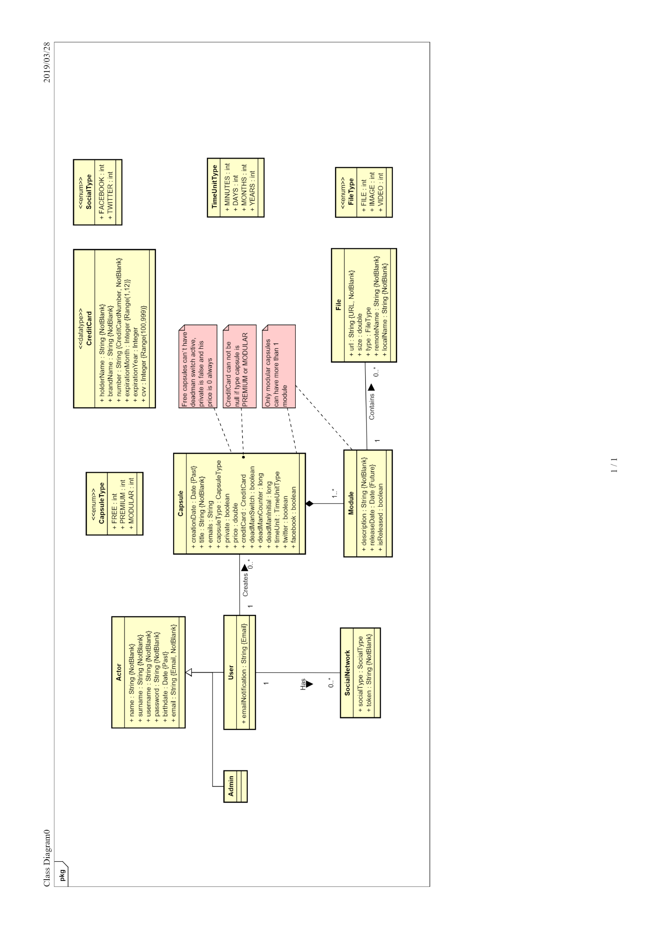

Figure : Conceptual model

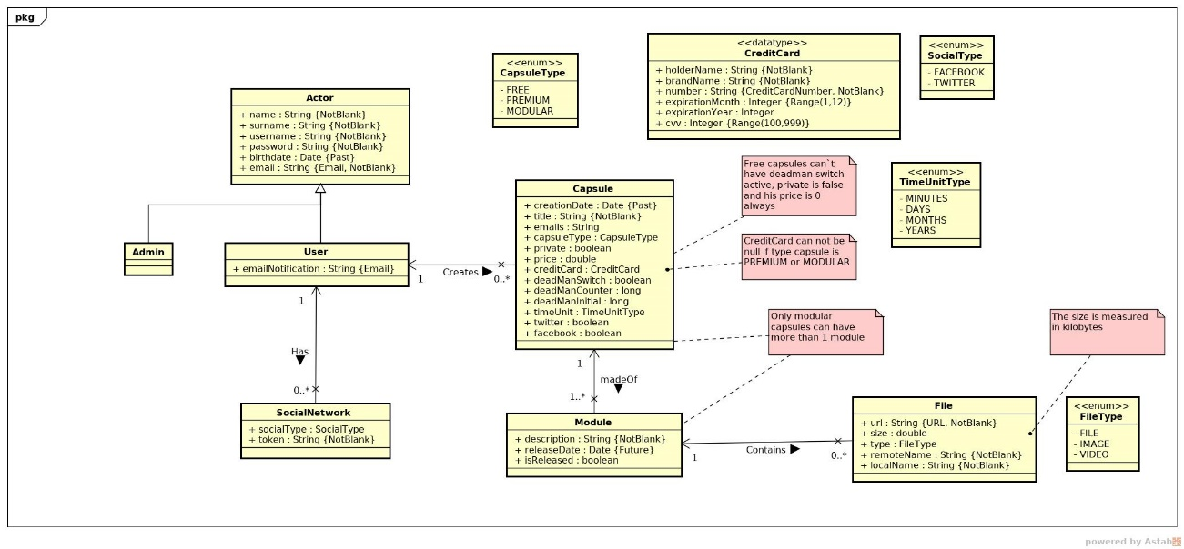

Figure : UML Diagram

We also have the first version of our application with is core use cases, whose demo will be displayed in our slides and that can be found at <https://capsulefy02.herokuapp.com/>

The release of our sprint in GitHub can be found at <https://github.com/pabreblob/capsulefy/releases> (Release 2)

A piloting plan for our pilot users, which includes a user manual and scheduled tasks.

All the documentation provided in the deliverable of this sprint

# Sprint 2 planning

This is the initial planification for our second sprint. It is not yet definitive, as it may suffer some changes during the meeting after class on April 1st.

## Week 1 (April 1st- April 7th)

|  |  |  |  |  |
| --- | --- | --- | --- | --- |
| Task | Start Date | End Date | Team member | Time estimated |
| Initial meeting, adjust planification | April 1st | April 1st | All members | 1.5h |
| Local settings | April 2nd. | April 2nd. | Daniel C. | 1h |
| User sign in | April 2nd | April 2nd | Juan R. | 2h |
| Remove expired capsules | April 2nd | April 2nd | Pablo R. | 1.5h |
| Social Network Integration: Twitter | April 2nd | April 4th | Rafael F. | 4h |
| Investigate payment options and take a decision | April 2nd | April 4th | Adrián C. | 2h |
| Fix pagination and search compatibility issues | April 3th | April 3th | Daniel C.  Juan R. | 1.5h each |
| Notify via email when a deadman timer is about to expire | April 3th | April 4th | Pablo R | 1.5h |
| Front end | April 4th | April 7th | Daniel C | 5h |
| Basic admin. Ban and unban users | April 4th | April 6th | Juan R. | 2h |
| Look for improvements in automations | April 4th | April 7th | Pablo R | 4h |
| Implement basic payment method | April 5th | April 7th | Adrián C. | 4h |
| PowerPoint | April 5th | April 6th | Rafael F | 3h |
| Collect information from pilot users | April 6th | April 6th | Adrián C | 1h |
| Rehearsal | April 7th | April 7th | Pablo R | 1.5h |

## Week 2 (April 8th- April 12th)

|  |  |  |  |  |
| --- | --- | --- | --- | --- |
| Task | Start Date | End Date | Team member | Time estimated |
| Meeting to discuss class and pilot user feedback | April 8th | April 8th | All members | 1.5h |
| User interface | April 9th | April 11th. | Daniel C. | 7h |
| Social Network Integration: Facebook | April 9th | April 11th | Rafael F. | 4h |
| Make Premium capsules payment-only but giving us a way to test them | April 9th | April 10th | Adrián C. | 4h |
| Basic admin: Dashboard with application data | April 9th | April 10th | Juan R. | 3h |
| Apache jmeter tests | April 9th | April 11th | Pablo R | 4h |
| SonarCloud tests | April 11th | April 12th | Adrián C | 2h |
| Allow user to edit their notification mail | April 11th | April 11th | Juan R | 2h |
| Sprint review and Sprint 3 planification meeting | April 11th | April 11th | All members | 1.5h |
| PowerPoint | April 11th | April 12th | Rafael F. | 3h |
| Deliverable documentation | April 11th | April 12th | Pablo R | 4h |

# Piloting plan

Our piloting plan will consist of:

* Creating a user manual with implemented core functions about our application so that pilot users may know what actions they can do in it. This manual can contain pictures or links to videos to explain its use.
* Creating a test case suite for pilot users to execute it.
* Creating an environment where users can try our application and give them credentials to log in and try it.
* Creating a form in order to know users’ opinions and get feedback to improve our product.
* Collect feedback from them, use it to improve our product and send them a new test case suit to receive new information.

## Test case suite

### Not logged user

* List and search public capsules
* Display public capsules

### Free capsules

* Create a free capsule and publish it into our website.
* Display a free capsule created by the user.
* Update free capsule
* Delete a free capsule created by the user.

### Premium capsules

* Create a premium capsule
* Edit capsule
* Edit module
* Delete module
* Delete capsule

## Important dates for our piloting plan

|  |  |  |
| --- | --- | --- |
| Date | Description | Person in charge |
| 30/03/19 – 06/04/19 | Pilot users receive and fill form | Adrián C. |
| 06/04/19 | Receive users feedback | Adrián C. |
| 08/04/19 | Planification using feedback | All |
| 09/04/19 – 12/04/19 | Develop | All |
| 12/04/19 – 22/04/19 | Pilot users receive and fill new form | Adrián |
| 22/04/19 | Receive users feedback | Adrián C. |
| 22/04/19 | Planification using feedback | All |
| 22/04/19 – 03/05/19 | Develop | All |
| 04/05/19 -12/05/19 | Pilot users receive and fill last form | Adrián C. |
| 12/05/19 | Receive users feedback | Adrián C. |
| 13/05/19 | Planification using last feedback | All |

## User form

User’s feedback will be collected through the following survey: <https://forms.gle/DWs2JPuyyd8hnbjg6>

The survey has been written in Spanish, as it is the main language of all our pilot users.

## User manual

A document on this same deliverable called “User Manual.pdf” includes the information necessary to use our prototype. The aim of that document is to make easier for our pilot users and evaluators to test our application. The form that will be provided to the pilot users will contain a explanation on how answer each of the questions too. A Spanish version will be available for our users, while the English version is the one that will be included in our deliverable for consistency.

## Testing environment and credentials

Every pilot user will be emailed a document with the user manual, the url of the testing environment and their credentials. For security reasons, this information will not appear in this document.